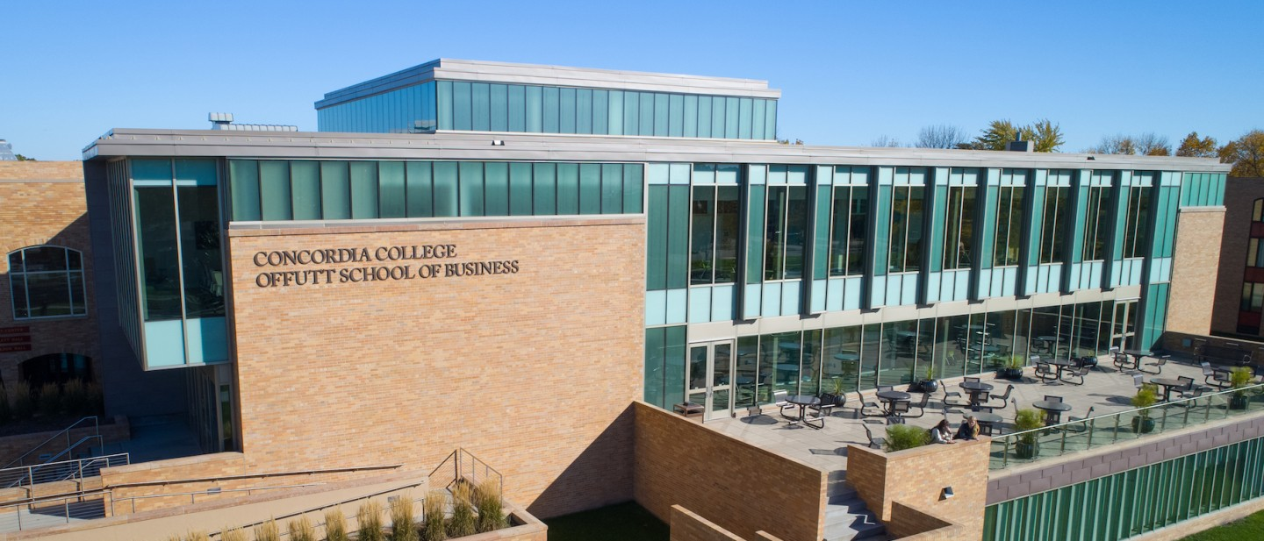

Project Proposal

|  |
| --- |
| Concordia Entrepreneurship Club |

|  |  |
| --- | --- |
| Course | **CSC 310 – Web Development** |
|  | |
| Team Name | **Pixel Pioneers** |
|  |  |
| Team Members | **Lucas Winger** |
|  | **Ella Anderson** |
|  | **Lennox Magak** |
|  | **[ Enter Team Member 4 Full Name ]** |

|  |
| --- |
| Executive Summary |
| **Your executive summary should resemble an elevator pitch: your motivation is to quickly persuade a decision maker to get involved in your project.** |
| * **What is the purpose of your project; what problem(s) does it address?** * **Why is your project important; why is it relevant? (NOTE: not in terms of the class to get a good grade)** * **Who could your project help; who is your audience or customer?** |
| The Purpose of this project is to create a personalized website for Concordia’s Entrepreneurship club in order to make the club more noticeable and to show other students about it. This project is important because it is hard to show off a club and make it enticing for new recruits. This website hopes to create a way for this club to reach out to other students who may be interested in joining. It will also create opportunities for people outside of Concordia to reach out to these future entrepreneurs to make connections and maybe some offers. |

|  |
| --- |
| Background and Problem History |
| * Explain the problem domain and relevant background information about your project * Provide a brief history of the problem; when did it start? What attempts have been made to solve it? * NOTE: Think in terms of your PROJECT, not in terms of this class |
| The problem is that it’s challenging to make this club stand out in order to encourage people to join. This is a problem for many clubs at Concordia since people tend to focus more on the music and sport-related clubs more and that causes many students to not even know about certain clubs. There have been many attempts to bring people in by bringing it up to classes, talking about it with friends, and hosting events. |
|  |

|  |
| --- |
| Solution |
| * How does your team plan to solve the problem? * What makes your approach different from other solutions? |
| People are more likely to engage with the club if they have an accessible and engaging way to do so. So, our team’s plan is to use social media because people have been able to post information online where it can be accessed by millions, and clubs have also taken to social media to increase their presence. But what they need is all that information in one place, not made over social media posts a couple times a year. A full website can fix that. |

|  |
| --- |
| Project Deliverables |
| * What will be the “product” of your team’s project? What documents will you create? |
| Our project's product is a website designed to be the central platform for the Concordia College Entrepreneurship club, including necessary code files like HTML and CSS, and media files like images and videos. |

|  |
| --- |
| Success Criteria |
| * How will your team define success? What aspects of your project can you quantify to objectively measure success? * NOTE: Think in terms of your PROJECT, not in terms of this class |
| Our team defines success by having a fully functional and adaptable website, with at least 15 functional pages. The project is size-adaptable for different monitor sizes and has sufficient admin control for upkeep after the semester is finished. There will be no errors on any of the pages (e.g. 404 error) or broken links. |

|  |
| --- |
| List of Required Project Resources and Materials |
| * What resources (books, websites, data sets, problem domain information sources, software, etc.) will be / have been required to complete your project? |
| Blackbox.ai  W3schools.com  Stack Overflow |